Project Development Phase
Performance Test Report – Power BI-Style Template
Implement Client Script & UI Policy (Incident)
Date | 1 October 2026
Team ID | SWTID-2026-4755
Project Name | Implement Client Script & UI Policy (Incident)
Maximum Marks | 10 Marks
1. Project-specific test context
Translate dashboard-style performance thinking into the Incident project by measuring repeatable form/list interactions and validation outcomes. No Power BI component is part of the Incident implementation.
The project uses a ServiceNow Incident form and list with one High Impact Control UI Policy and three Client Scripts. The test focus below adapts the ZIP reference report type to the Incident project; it does not claim that a live execution was completed during report preparation.
2. Project metrics / equivalent parameters
S.No. | Parameter | Project-specific values / evidence
1 | Data viewed | Incident list and form records grouped by Impact and State.
2 | Validation profile | High Impact = 1, Medium Impact = 2, Assigned To empty/populated, State edited from list/form.
3 | Decision quality | A successful response must include both acceptable interaction speed and correct policy/script outcome.
3. Test scenarios and results
Test Case ID | Scenario | Test Steps | Expected Result | Actual Result | Status
PBI-PT01 | Read-heavy Incident list usage | Open Incident list repeatedly across fixture sizes and Impact groups. | List returns records within agreed threshold and does not bypass control scope. | Pending execution | Pending
PBI-PT02 | Mixed form interactions | Change Impact, edit Assigned To, and submit valid/invalid records. | No unacceptable delay; correct message and save decision are returned. | Pending execution | Pending
PBI-PT03 | Performance summary | Compare baseline and controls-enabled interactions. | Results identify any client-side overhead and confirm outcome correctness. | Pending execution | Pending
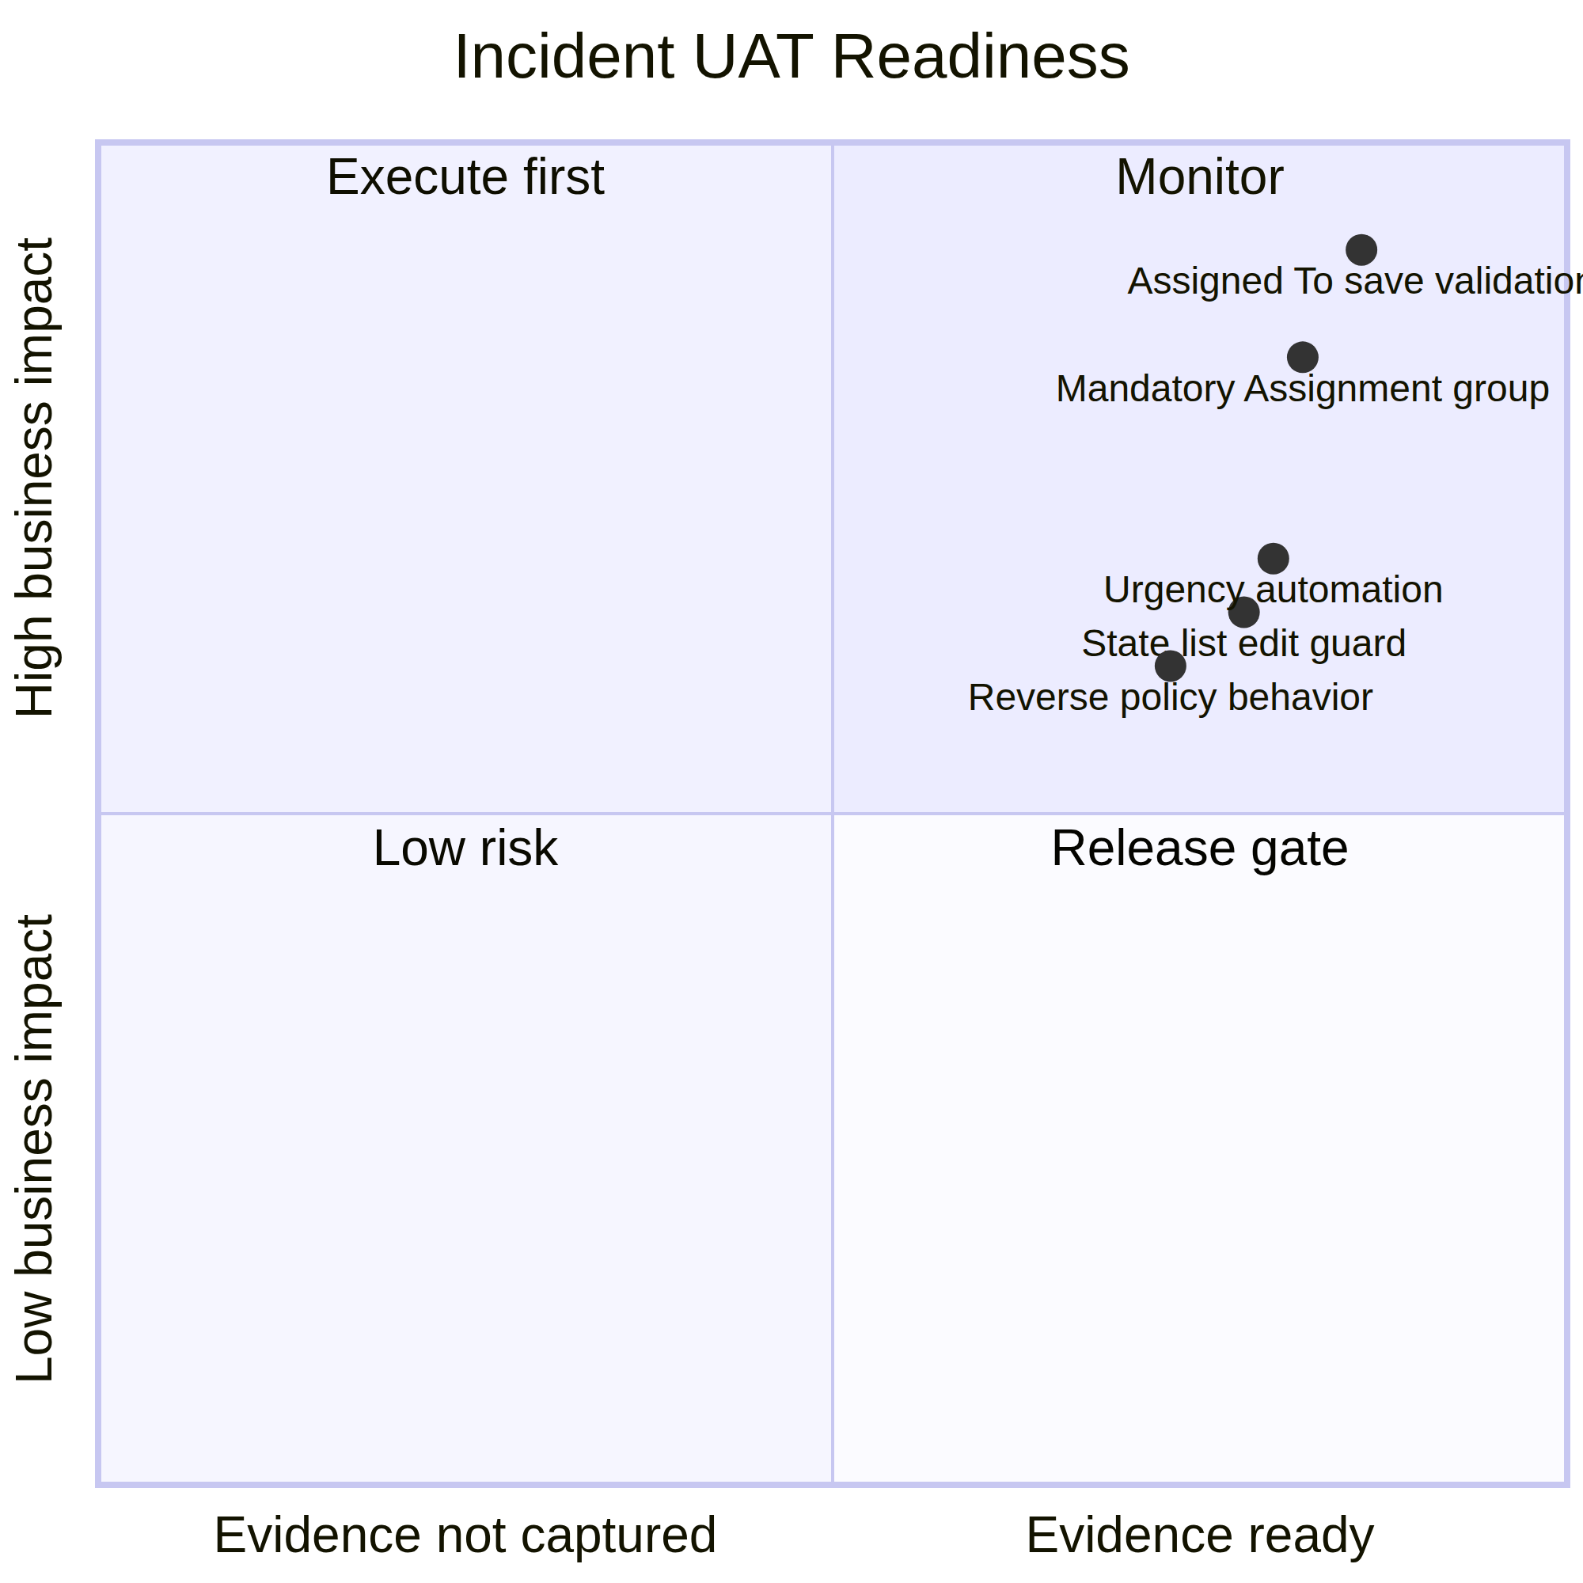
Original project-specific visual created for this Incident report.
4. Interpretation and evidence note
The project equivalent of dashboard accuracy is not a visual chart score; it is the combination of responsive interaction and correct Incident policy enforcement.
5. Execution status
Status at report preparation: Pending execution in the target ServiceNow instance. The source project PDF defines the configuration and expected behavior, but does not include live screenshots, response-time logs, or execution timestamps. Record those artifacts against each test case before final sign-off.
6. Conclusion
This report provides a project-specific Phase 5 testing baseline for Implement Client Script & UI Policy (Incident). The selected scenarios verify conditional field behavior, urgency automation, save-time validation, list-edit protection, and form-based updates while preserving the traceability expected in the supplied reference reports.

